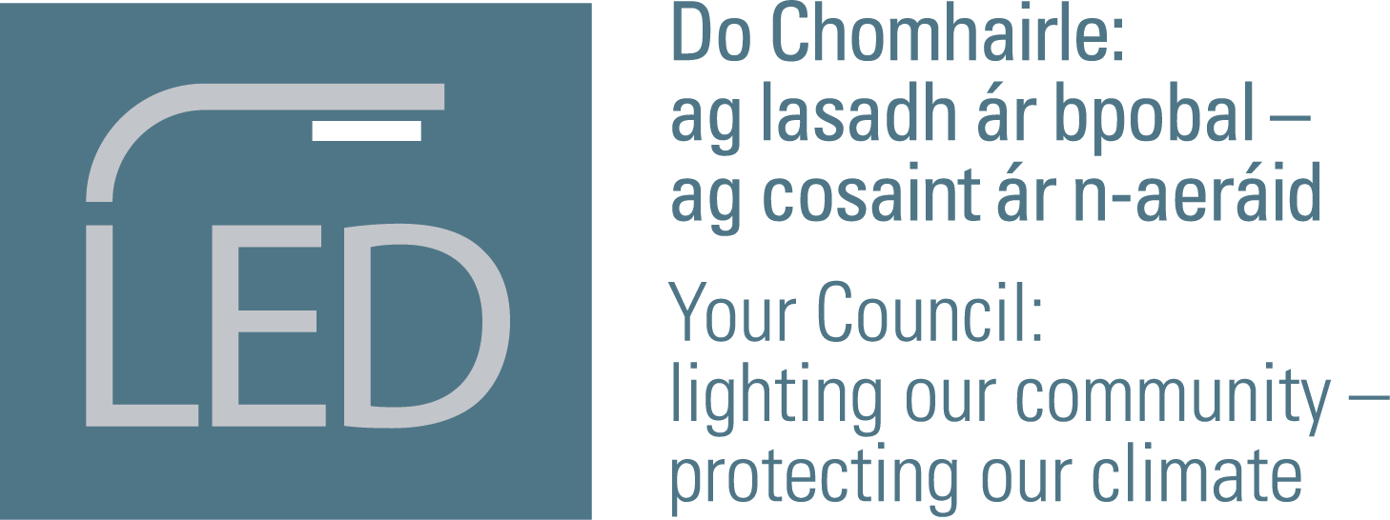

Local Authority Public Lighting Energy Efficiency Project

Aim of the Project
The primary aim of the project to enable Local Authorities reach their statutory energy efficiency target to be 33% more energy efficient by 2020. The Project will also significantly help LA’s reach their new 2030 target of 50%.
Secondary objectives are to survey and collect data on the condition of the Public Lighting infrastructure. This will enable Local authorities to strategically plan and invest in the upgrading of Public Lighting service into the future.

Local Authorities participating in the Project
There are 24 Local Authorities participating in the Project
Southern Region: Cork County, Kerry, Limerick City and County, Waterford City and County, Clare,
Eastern Region: Carlow, Kilkenny, Tipperary, Wicklow, Kildare, Offaly, Westmeath, Meath, Longford and Louth.
North West Region: Donegal, Mayo, Sligo, Leitrim, Longford, Monaghan, Cavan, Roscommon, Galway City, Galway County.

Region | Quantities of Luminaires
Southern Region | 91,262
Eastern Region | 113,992
North West Region | 75,006
Total | 280,260

Map

Useful statistics and data about the Project
- Approx. 280,000 lights to be retrofitted in this project (480,000 in total in all of Ireland)
- 24 project LA’s spend in excess of €22 million/year in energy costs for Public Lighting.
- The 24 LA’s spend over €7 million a year in general maintenance of the Public Lighting asset.
- Project is expecting to achieve a minimum of a 50% energy efficiency in energy consumption.
- Once fully installed the 24 LA’s will;
  - Save over €15 million in energy and reduced maintenance costs per year
  - Avoid 31,000 tonnes of CO₂ per year being produced.
  - Energy savings from this Project per year is equivalent to annual energy consumption of 4100 domestic houses or 7700 cars.
- Estimated Capital costs of the project is approx. €151 million
- The Climate Action Fund is supporting to project with a grant of €17.5 million to accelerate the implementation.
- Once completed the 24 LA’s will have met their 2020 energy efficiency targets of 33% and will be significantly advanced on the glide path to their 2030, 50% efficiency target.

